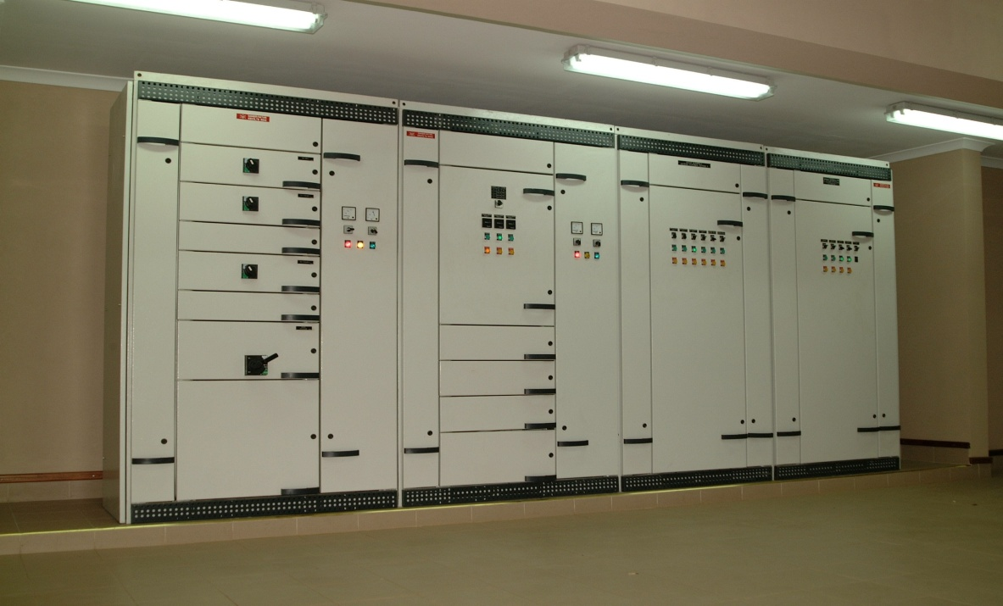

###### M&E Engineers & Contractors

UNICON INTERNATIONAL LIMITED

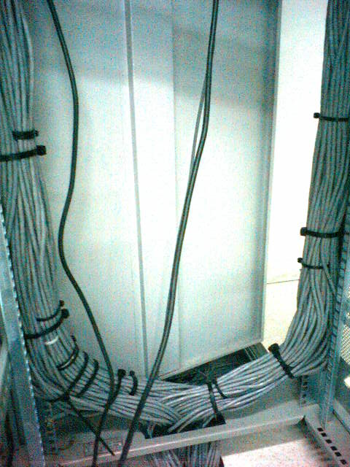

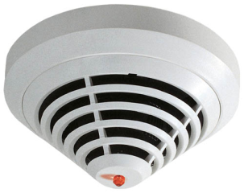

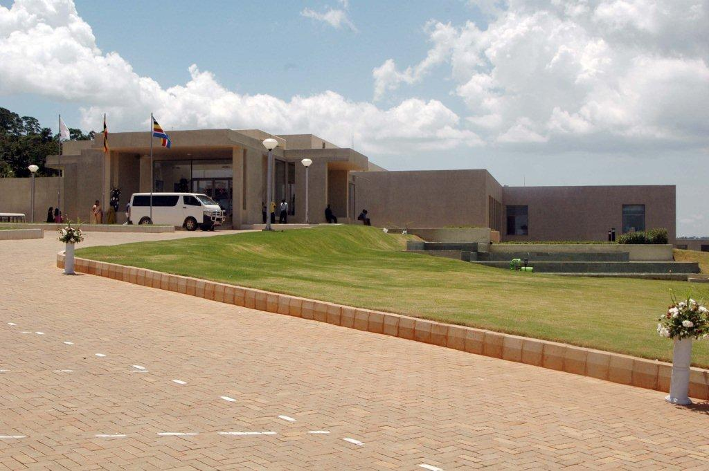

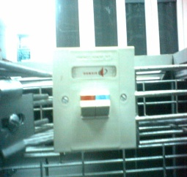

***About Us***

**UNICON Int. Ltd**. is an Electrical, Mechanical and ICT contracting, engineering and consultancy Company dealing with installations, configurations, support or maintenance of the system installed by us or third parties. **UNICON** is rather young, but fast growing company, consisting of team of highly qualified staff with vast experience and reputation in Uganda and East Africa, joined together with the vision of improvement of services in these fields to the best interest of public and private Clients in the region.

We help the client or end user in our projects to create an ambience of their choice by offering customized power solutions to their individual taste thus creating comfortable, effective living and working environments and ideal operating conditions.

The name **UNICON** is synonymous with quality and performance within the construction industry and beyond. Our knowledge and expertise has been earned through qualifications and years of experience.

Our strength include the vast infrastructure capable of offering design, procurement, project management and execution of projects of different sizes and complexities.

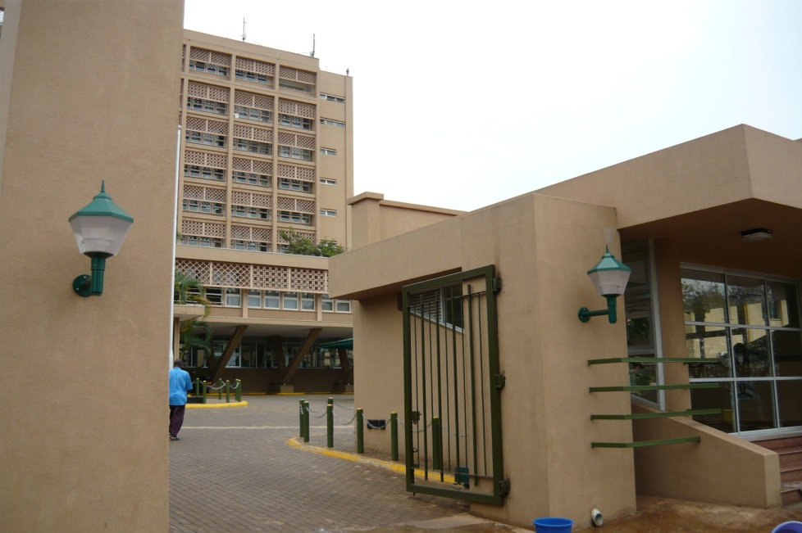

***Company Profile***

UNICON, is mainly involved in Electrical and Mechanical Engineering and contracting, but also undertakes turnkey design/build projects in order to provide the client with the best solutions and excellent value engineering using the latest technology and systems.

We undertake all associated works related to project requirements like,

* Supply, installation & commissioning of various electrical installation works in buildings, schools, hotels, industrial objects
* HV and LV Transmission Lines, Substations and Rural Electrification works,
* Supply and installation of Generators, UPS and Voltage Stabilizers,
* Suppliers of electrical materials and equipment
* Voice/& Data cabling, LAN & WAN networks
* PABX supply and installation
* CCTV surveillance systems
* Public Address Systems
* Fire Detection and Alarm Systems
* Access Control, Power Stations
* Air Conditioning, ventilation and mechanical works, to mention but a few.

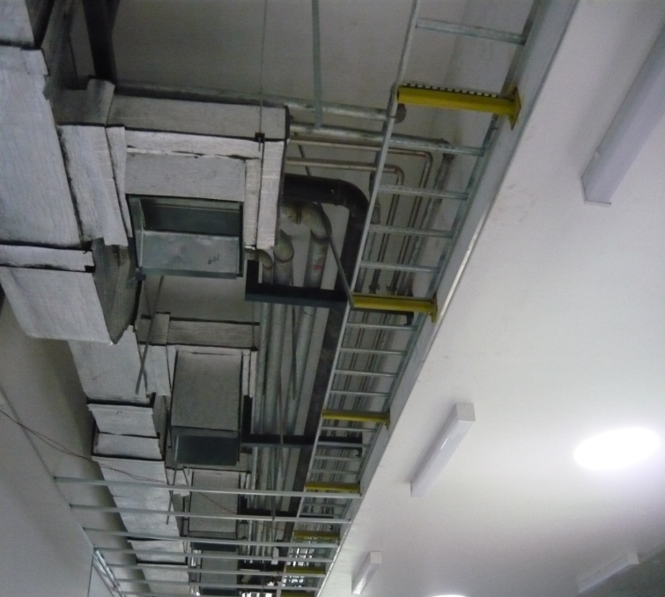

We follow a standard international operating system and guidelines to ensure that all our projects are completed within the time frame. Subsequently, we offer quality, effective management, workmanship and service backup that is unsurpassed and incomparable.

***Staff Resource***

Unicon’s strength among others, include a clear corporate structure and planning, multilingual and well qualified permanent staff of Managers, Co-ordinators, Contract and Project Managers, Site Managers, Electricians and efficient back office staff constituting, Financial Managers, Procurement Managers to mention but a few.

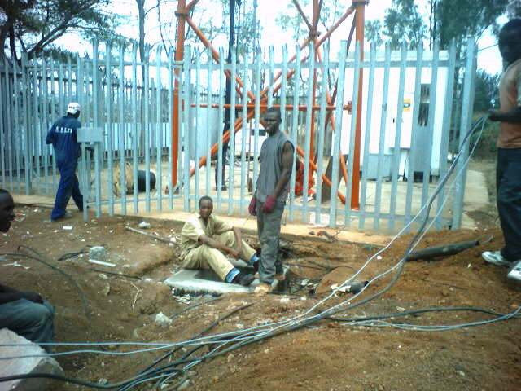

The cosmopolitan nature of our work force at all levels our organization enables us to fulfill our aim of providing a high level of client service and satisfaction.

Our Personnel are versatile to all kinds of working environments and standards.

Frequent training sessions conducted by management in all aspects of our operations and technology updates, ads up to our staff’s performance in their respective fields.

Some of the aspects of training include quality control, health & safety, first aid, management skills and updates on latest technology and equipment to ensure excellent efficiency and expertise enabling them to work in close collaboration with consultants, architects and clients

Below we have a list of some of our staff with their qualification and years of experience.

* Name: Mr. Dejan Kostic,

Nationality: Serbian

Position: Managing Director

Qualification: B.Sc. Economics

Experience: 29 years

* Name: Mrs. Zorana Kostic,

Nationality: Serbian

Position: General Manager

Qualification: Masters. Sc. Civil Engineering, (Chartered Engineer)

Experience: 29 years

* Name: Bernard Raruoch

Nationality: Kenyan

Position: Project Manager / Technical Manager

Qualification: Diploma in Electrical Engineering

Experience: 30 Years

* Name: Ian Forbes

Nationality: British

Position: Contracts Manager

Qualification: Chartered Quantity Surveyor

Experience: 46 Years

* Name: Rade Bozic

Nationality: Serbian

Position: Plant, Equipment & Workshop Manager

Qualification: Mechanical Engineer

Experience: 48 years

* Name: Ssekiro Levi

Nationality: Ugandan

Position: Foreman Instrumentation

Qualification: Diploma in Electrical Engineering

Experience: 8 years

* Name: Simon Mateka

Position: Plumbing Foreman

Qualification: Diploma in Mechanical Engineering

Experience: 18 Years

* Name: Anthony Andany

Nationality: Kenyan

Position: Site Foreman – HVAC and plumbing

Qualification: Higher Diploma plumbing

Experience: 23 years

* Name: Robert Assimwe

Nationality: Ugandan

Position: Finance & Administration

Qualification: Accountant

Experience: 20 years

* Name: Augustine Matovu

Nationality: Ugandan

Position: Linesman HV Trade Test Grade II

Qualification: Foreman/Linesman Overhead lines

Experience: 12 years

* Name: Stephen Odongo

Nationality: Ugandan

Position: IT, CCTV, Fire detection Foreman

Qualification: IT & Telecommunication Engineering

Experience: 7 years

* Name: Joseph Opio

Nationality: Ugandan

Position: Site Foreman

Qualification: Diploma in Electrical Engineering, Class B “ERA” permit

Experience: 20 years

***Procurement***

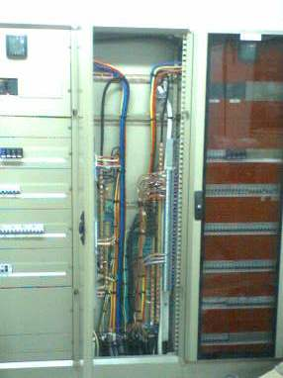In comparison to our craftsmanship, the use of superior materials is second to none. This is selectively done by our procurement team which maintains a database of market contacts and vigorously surveys all markets for the highest quality and supplies to be sourced.

The materials we use are sourced both locally and abroad for maximum choice. We keep data bases for all the materials we buy, for future cost comparison so that we are able to meet our client’s needs and budget.

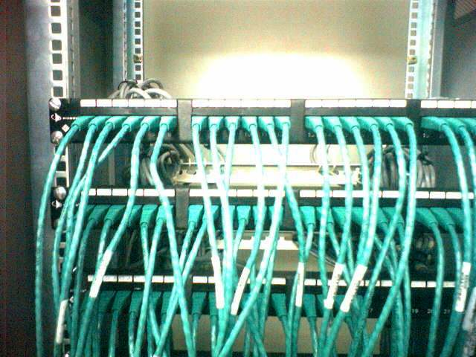The economic benefits in this department by the maintenance of high standards and procedures guarantee our client optimum competitive rates for materials and equipments.

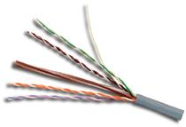

***Quality Assurance***

UNICON is committed to operate a quality assurance system which is in accordance with the British and ISO standards.

Application of these quality systems enables us to demonstrate to our clients’ compliance with all aspect of the contract specifications.

We also have Siemon Cabling Systems U.S.A certified designer and Installer in our company, which means that our Voice and Data Installations are according to the laid down regulations and specifications by this giant voice and data cabling systems manufacturer.

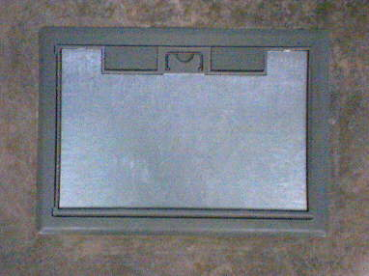This also means that for every project done by us, using Siemon cabling Systems materials and equipment, a warranty of up to 20 years, for Cable, Labour and Application will be given to the client.

We go all this way, so as to assure our clients of good service and an installation which will fully satisfy them.

***Execution/Construction***

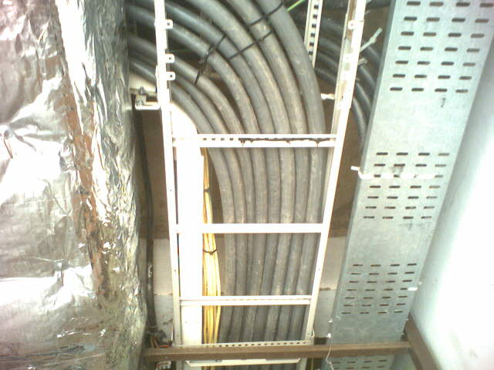

After thorough project planning has been done, any elements where off-site prefabrication would be beneficial can easily be isolated. This optimizes on-site installation, bringing about greater efficiency, reduced costs and shorter installation periods.

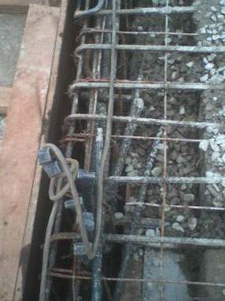Our industry is Labour intensive and we place great emphasis on the quality and accuracy of our human resources. Our company’s installation team are dedicated tradesmen, well-motivated and highly skilled. They are supervised by thoroughly trained and experienced field engineers and foremen.

We recognize and recruit highly talented professionals to keep-up the high standards. This is maintained by continuous and frequent in-house training sessions and performance appraisals.

We undertake this in order to ensure that all our projects are executed successfully, with minimal disruption to other trade activities.

***Commissioning***

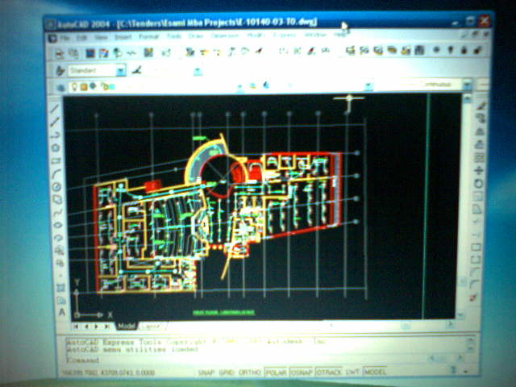UNICON experienced and qualified engineers ensure that the pre-commissioning of systems is effectively executed. This can be done in conjunction with, or independently of, the client’s engineering team or consultant.

Detailed inspection of specified requirements is made and close attention paid to any remedial defects. In this way, UNICON can be sure that the end acceptable for handover.

A copy of a thorough report of tests done at the client’s premises is always sent to the client and consultant, so that there can always be a referral should there be any problem with the installation, or when authorities require the tests results. This is normally sent in both hard copy and soft copy.

Regular up-dating of working drawings and compilation of operating and maintenance manuals is carried out to ensure the client’s engineering team can easily interface at project handover.

***Electrical Installations***

At Unicon, we work with the best Electrical Installations Material manufacturers, who are well known in the field and whose materials are rated the best in the world.

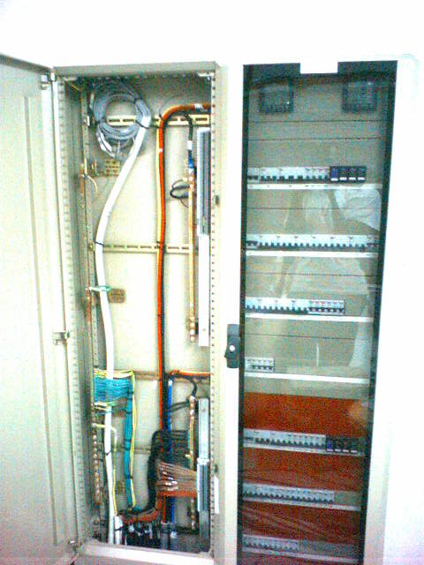Among the manufacturers we work with include:

* Bosch Security Systems (PTY)
* Power Technics Limited
* Fitzgerald Lighting UK
* Switchgear & Controls Ltd.
* Specialized Power Systems
* Philips Lighting
* Marshall Tufflex
* Mantrac (Caterpillar)
* ABB
* MEM
* MK
* Clipsal
* Legrand, and many more.

With these installations, we normally try and advice the client where necessary, but also try and work with the materials which are specified by the consultant so as to have their custom design of the project.

As Electrical contractors we work and follow specifications and regulations of international standards bodies, both local and International, governing Electrical Installations e.g. ERB, IEE, so as to avoid accidents during Installations and future accidents, which may occur as a result of poor workmanship.

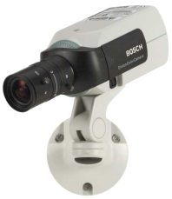***Electronic Security Systems – Bosch***

We are the authorized dealer-distibutors and installer of Bosch Security Systems in Eastern/Sub-Saharan Africa. For over 100 years Bosch name has stood for quality and reliability. Bosch Security Systems proudly offers a wide range of:

* ***Fire Detection and Alarm systems,*** 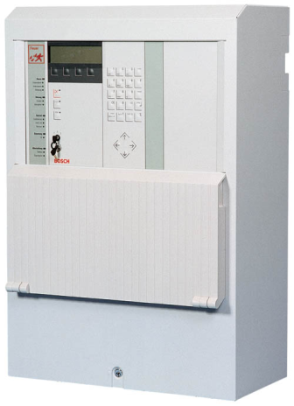
* ***CCTV and Video surveillance, IP Video systems***
* ***Management and Communication systems (Public Address, Conference and Congress Systems),***
* ***Intrusion and Social Alarm systems,***
* ***Smart building management systems for integration of all services in one, etc.***

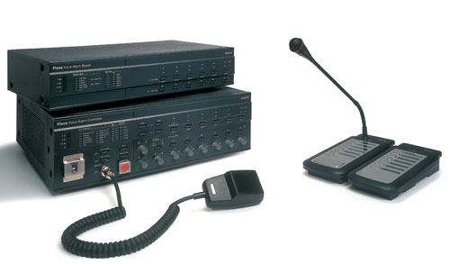Being a Bosch Partner, Unicon is supplier of choice of innovative technology backed by highest level of service and support. When you need solutions you can rely on, choose Bosch and Unicon.

***Bosch equipment has been installed in the following premises in Uganda: Serena Hotel & Conference Center, Sheraton Hotel, Entebbe Airport, Statistics House – UBOS, Workers House, Uganda Police City Surveillance and many others.***

***Information and Communication Technology Installations***



At Unicon we believe that every business or institution in the world has to have a very good ICT installation as this is where all the communication to their client depends. ICT has proved to be the backbone of every business such that, many institutions are now investing heavily in it, so that they cater for every new IT technology coming into existence.

As we all know, ICT is a competitive industry with every manufacturer trying to come with something new every day, so as to become the market leaders. With this in mind, it has become very hard investing in your LAN system.

This is why, at Unicon, apart from being your ICT installers; we have professionals who will advice you on the type of Cabling System to be installed on your premises so that you do not have to invest again in it when a new technology comes in.

***Voice and Data Installations***

Structured Cabling, is the backbone of every LAN, as even though companies have come up, with the wireless system, cabling systems, have proved to be consistent.

This is why at Unicon, we have invested in this department, so as to give our clients the best product and services, which will be a value to their money.

Unicon is also a SIEMON Cabling System U.S.A. certified Designer and Installer company. This means that for every system done by us, using Siemon cabling System products, will have a warranty for a very long period of time. Recently, our staff has undertake a training and obtain certification by CLIPSAL, Australia as well as CISCO Systems, in order to be able to give our Clients the wider choice and better service.

We have a good workmanship, and every project done by us comes with a warranty for Labour, Product and Cable. Just like our Electrical Installation department, we work with the best cabling systems manufacturers in the world. These include:

* Siemon Cabling Systems U.S.A
* Giganet Solutions
* Legrand
* Netsan Cabling System
* Clipsal System
* D-Link Systems
* Krone Systems

Unicon is a fully ICT company, which means that, apart from Installing cabling systems, we also supply and install active equipments such as Network Switches, Telephone PABX’s, Computers, Firewall Hardware and Software applications as per the client requirements.

We work with the following Active equipments manufacturers:

* Siemens
* Cisco
* D-Link
* Accton
* Alcatel
* Hewlett Packard

***Projects***

Engineering excellence has been achieved by UNICON through the various and vast different kinds, sizes and complexities of projects successfully executed by our staff over the years.

We deliver full project packages, from design implementation to after installation maintenance, thus delivering highest quality standards to achieve client satisfaction.

Some of the projects we were involved include:



* Electrical and mechanical installation at New Classrooms and Ambulance at International School of Uganda, Lubowa, Kampala
* Voice and Data Installations at New MTN Redundancy Switch – Kigali
* Air-Conditioning installation at the MTN Redundancy Switch – Kigali – installation and commissioning of 7 Split units of 100.000 BTU Uniflair
* Access Control Systems at MTN New Offices – Kigali
* CCTV at MTN New Offices – Kigali
* Electrical, Voice & Data Installations at the New URA Offices, European Union Offices in Crested Towers
* Voice & Data Installations at the African Motors offices on 7th Street – Kampala
* Supply of electrical materials to MONUC UN mission for Congo and South Sudan, Log-base in Entebbe,
* Electrical and Air Conditioning installations for European Union Housing Estate in Juba, South Sudan for Terrain Services Ltd.,
* Electrical, Mechanical, Voice & Data and Air Conditioning Installations at MOFPED Main & Treasury Building and Parking Yard Remodeling and Refurbishment Project for Complant Engineering & Trade,
* Electrical Installations, CCTV, V&D and Access Control at Plot 2A Kampala Road, Head Quarters for Global Trust Bank,
* Construction of 11kV Distribution Line in Bombo Barracks for Ministry of Defense, UPDF,
* Air Conditioning Installation for Centenary Rural Development Bank – Entebbe Road and Nakivubo Branches,
* Electrical and Voice and Data Installations, CCTV and Access Control at Refurbishment of Telecom House in Kigali, Rwanda for Roko Construction (Rwanda) S.a.r.l.
* Electrical Installations at New Orange Shops in Kampala and Entebbe for BVS Milano Construction
* Electrical Installations at New Abacus Parenteral Drugs Factory in Mukono,
* Supply and installation of CCTV Distribution Amplifiers and Plazma TV sets to Parliament of Uganda
* Electrical & Mechanical Installations at Proposed New Office Park at Nakasero Road for Nakasero Towers Ltd.
* CCTV and Access Control installations at German Ambassador’s residence, Kampala,
* Voice and Data, CCTV, Access Control electrical fit-out of Global Lotto Offices at Nakasero Towers Building,
* CCTV installations at Sports TV HQ, Kampala
* CCTV installations for Roofings Limited at the New HQ in Lubowa and New Factory in Namanwe,
* Voice & Data, electrical fit-out of Agribusiness Trust’s New Offices at Nakasero Towers,
* Electrical and Plumbing Installations at New Mutesa II Shopping Mall, Katwe Kampala
* Supply and installation of PABX and Voice & Data structured cabling at New Centenary Rural Development Bank HQ (Mapera House) at Kampala Road for Roko Construction Ltd.,
* Supply of the camera software licenses, servicing and upgrading of the system for Uganda Police Force’s CCTV command centre,
* Installation of the CCTV surveillance site in Entebbe for Uganda Police Force
* Repair and service of the Bosch CCTV system at Lake Victoria Serena Resort,
* Electrical & Plumbing installations for New Apartment Block estate for Ezra Enterprises at Nalubale Link
* Electrical Installations at New Maize Mill for Aponye Uganda LTD at Nalukolongo
* Construction of Mockup Rammed Earth Wall and Solar Roof Structure for Emergency Life Support for Civilians at Entebbe
* CCTV installations at Kazi Foods Warehouses,
* Electrical Installations at Proposed New Commercial Development at Burton Street for Aponye Ltd.
* Kigali Convention Centre – Consultancy, Audit, Commissioning and Certification by VdS of Bosch Fire Detection and Alarm system at New Convention Centre & Hotel
* Furniture Fit out of British High Commission New Viza Center at Victoria Court
* Security Systems at New Sadolin Factory, Namanwe Industrial Area – Fire Alarm and Detection, Intruder Alarm
* UNHCR New Offices at Kololo – Supply, Installation of CCTV, Fire Detection and Access Control
* Electrical and Fire Installations at New French School in Mukono for Umoja Ltd.
* Construction services for APRU Mining Project in Kikagati, Isingiro Ph I & Ph II
* Automatic Fire Suppression, CCTV and Access Control for 33/11 KVA 40 MVA Transformer Substation Namugongo
* CCTV surveillance system for Uganda Police Force Workshop in Kampala
* CCTV surveillance installations for Uganda Police Force at 8 Sites and Forensic Department
* Automatic Fire Suppression, CCTV and Access Control for 33/11 KVA 40 MVA Transformer Substation Moniko
* Automatic Fire Suppression for 33/11 KVA 40 MVA Transformer Substation Mbale & Bombo
* Extension & Connection of Power Line to Staff Houses and SUEZ Yard at Katosi Drinking Water Treatment Plant and Nsumba pumping reservoir

***Current Projects:***

* Electrical Installations & Fire Detection at Bugolobi Waste Water Treatment Plant (2 x 1.6 MVA 11kV/LV Transformers, MDB + 8 x Motor Control Centers, Power Cabling & Reticulation of complete Site, Instrumentation cables, Fire Alarm & Detection, Testing & Commissioning)
* Kabaale International Airport Project in Hoima - Electrical & Mechanical Installations at Cargo TERMINAL Building
* Kabaale International Airport Project in Hoima - Electrical & Mechanical Installations at AGL SUBSTATION - ADDENDUM NO. 1
* Kabaale International Airport Project in Hoima - Electrical & Mechanical Installations at AIR RESCUE & FIRE FIGHTING BUILDING
* Design, manufacture, supply, installation, testing and commissioning of SCADA equipment for automation of PACMECS network including training of staff on operation/use and maintenance of SCADA equipment - REA/SUPLS/17-18/00307 – Sub-contract for installation of primary equipment

